Prototype- Section 4
4a, Areas to be included in the prototype
In this section of the prototype analysis, I will be justifying the use and purpose of the prototype itself, as well as the inclusion of each aspect within the prototype. This includes stating the features that will be within the prototype as well as well as their function, purpose and how they meet the requirements. I will then develop the prototype itself, and conclude this section of the project by showing the code used to make the program as well as self-evaluating it.
One of the reasons for the production of a prototype is because the prototype can be used as a reference when discussing the final product itself with Mr Joot and the other stakeholders. This being to ensure that the project is going in the correct direction based upon both the requirements and Mr Joot’s desire for the program, and If there are any issues; for it to be addressed in the final product.
Also, the prototype is purposed to show that the final product is both realistic and attainable in terms of scale and structure. This is because I may not have the resources to make an extremely complicated solution, and If I go straight into the final product, I may be unsuccessful.
For this section, I will be developing various forms which correspond to the functions required of Average Joot’s Gym. The main functions required include:
- A login, providing different levels of access
- The ability to add, modify and delete entries on a table, as expected from a standard database management system.
- The ability to login to access the database, and potentially include different levels of access.
- The ability to view the .csv files within a DataGridView, clearly seeing the labels and the rows.
- The ability to analyse the database, most probably via charts and graphs.
- A password protected table for userData, which is inaccessible even to users.

Within my prototype, these are the areas I wish to include:
- Member Management
- Trainer Management
- Program Management
- Booking Management
- Other Staff Management
- Progress Management
- Salary Management
- Facility Management
- User Management
- Member Analysis
- Trainer Analysis
- Program Analysis
Judging the scale of the prototypes, the best course of action would be to start with the User Management, this is because the user management is required to make a login access for the database, however: due to the scale of such data such as Members and Trainers, I may opt to start from them instead, because user management and login functions can be added later in development as the feature is relatively small in comparison to the other required features.
Afterwards, I will begin the management of the other tables, this being because I have a reference point once completing the forms for the addition, modification and deletion of Trainers and Members. Throughout the prototype, I will be opting to receive feedback or opinions from Mr Joot, for small changes or features that may be implemented within the prototype.

4b/4c. The Prototype
Upon starting the program, this is the login screen you will be prompted at. There will be two text boxes and a button. One textbox is for the user to input a username and the other textbox is for the user to input a password. The form will then conduct a search of the .csv file corresponding to the username and password inputs, and see If there are matches. If there is a match, a “success” messagebox will appear, followed by the main menu form.
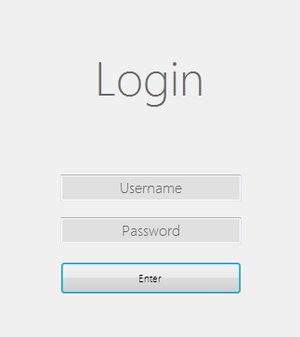

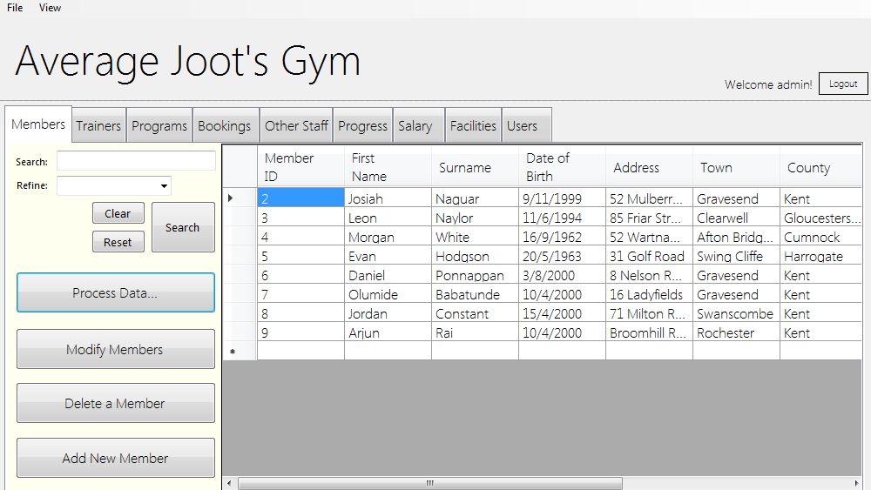
This is the main menu you will be prompted to when you’ve logged in. There is a tab view below the logo, in which the user can navigate through the different tables. On each tab, there is the table itself, with a search/refine function. There are then 4 buttons on each tab excluding the ‘clear’, ‘reset’ and ‘search buttons which correspond to the search/refine feature, these buttons will open the forms corresponding to their label e.g. If you click, ‘Delete a Member’, this will take you to the delete member form. There is also a process data button, which takes you to the analysis form.

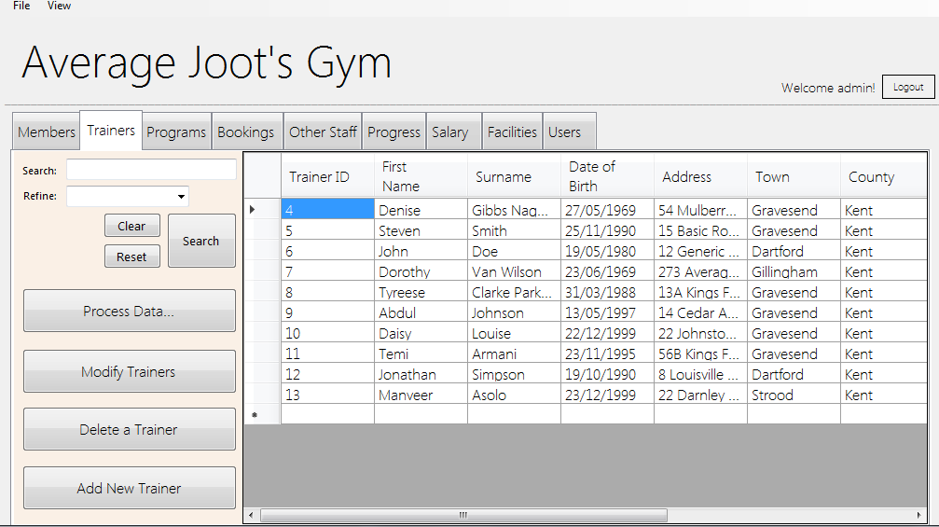
The same also applies for the each different section, and I’ve ensured that there is consistency in terms of button and table layout.

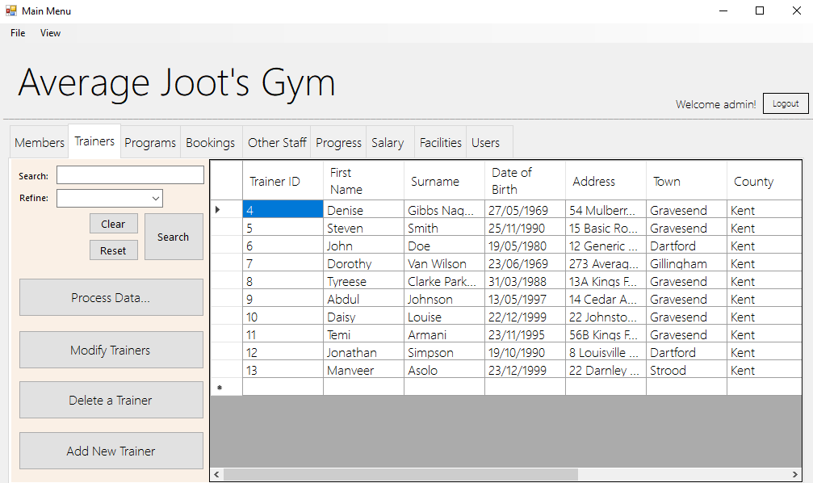

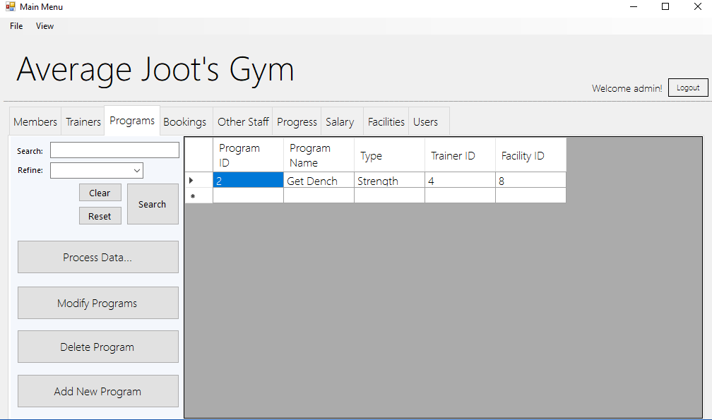

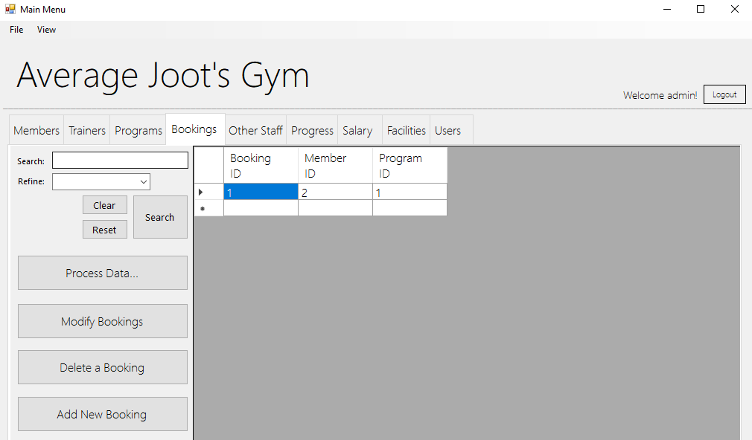

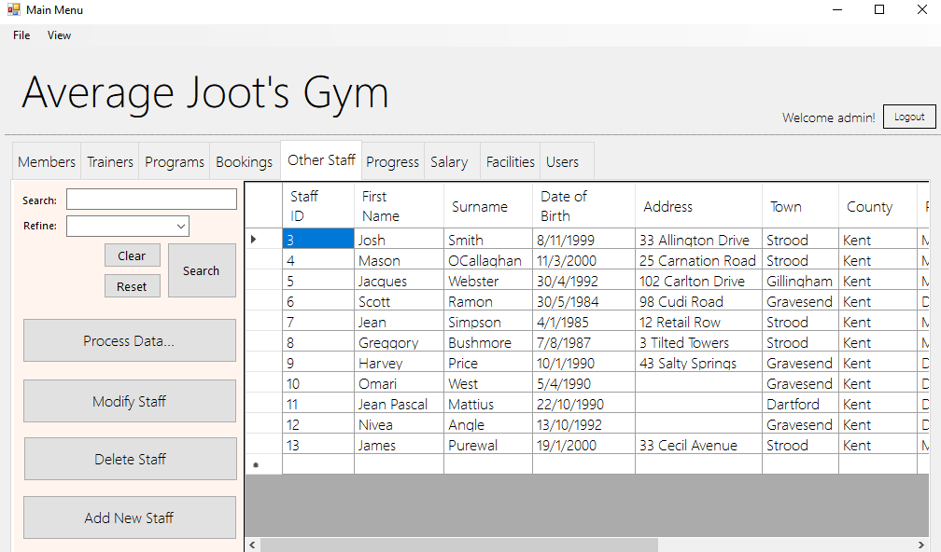

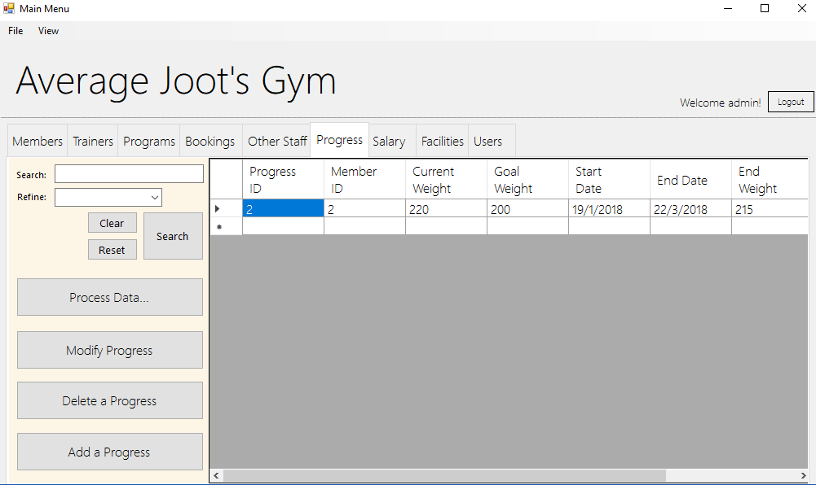

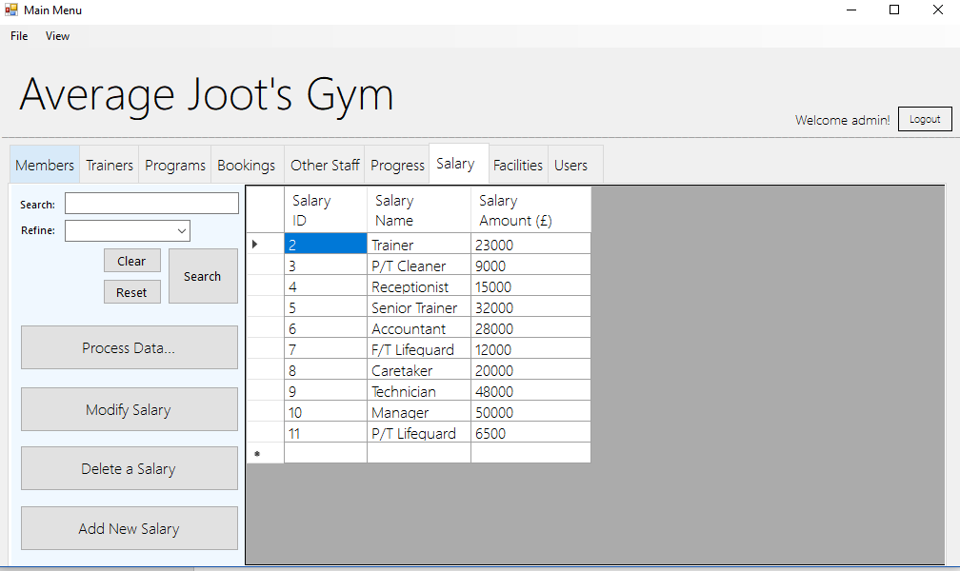

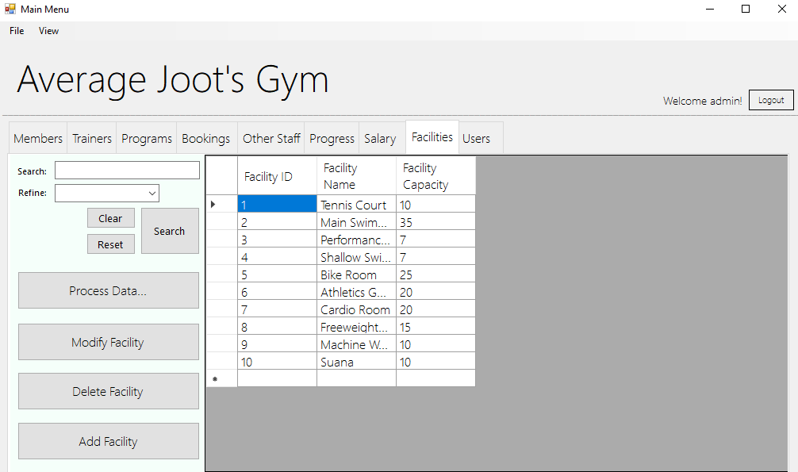

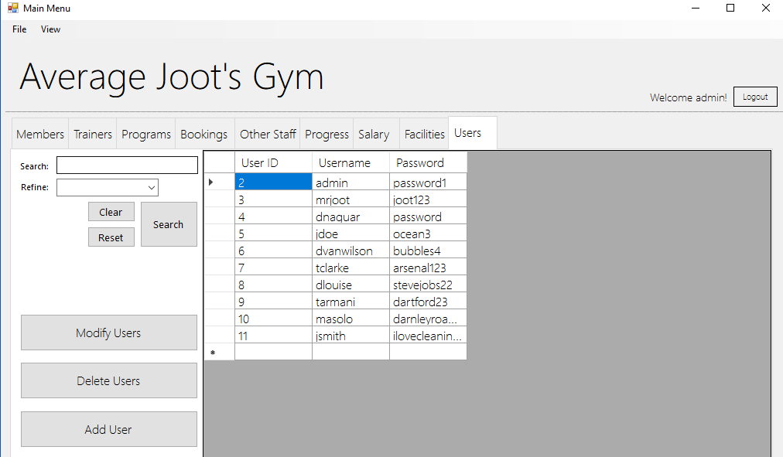

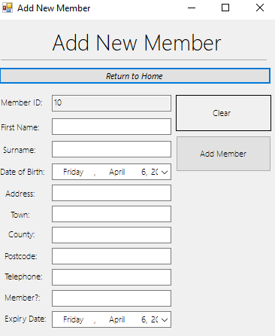
This is a form for adding a new record to the table. In this example, there is the member addition form. There is the label on top followed by a “Return Home” button below, there is then the textboxes, date/time boxes for input as well as labels which correlate to the purpose of each textbox. Then there is a clear button, which clears all textboxes excluding the new ID, and an “Add Member” button which initiates the validation subroutine as well as adding the member to the list. The three validation types I used was presence check, type check and range check. These validation types can be found on all the “Add ____” forms to ensure there is consistency.

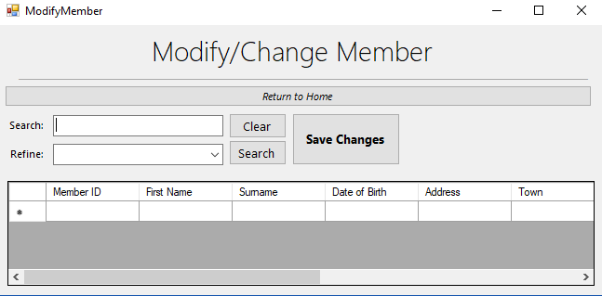
The Modify/Change Member form used a similar search method which is found on each tab in the main subroutine. The user can modify the data within the DataGridView and the “Save Changes” button overwrites the current record with the new record based on its unique identifier (ID).

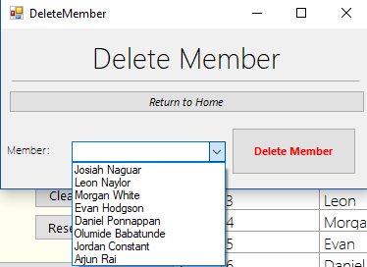
The delete member form shares a similar style to the add and modify forms, however: uses a drop-down menu which enables the user to select the item they wish to delete. This name selected will correlate to the ID, and the record associated with the ID will be deleted when the “Delete Member” button is clicked.

Code For Main Subroutine
Imports System.IO
Public Class MainMenu

Dim needpas As Boolean = False

Dim MemberFile As String = "member.csv" 'This loads the file data into the MemberList structure.
Dim TrainerFile As String = "trainer.csv" 'This loads the file data into the TrainerList structure.
Dim ProgramFile As String = "program.csv" 'This loads the file data into the ProgramList structure.
Dim BookingFile As String = "booking.csv" 'This loads the file data into the BookingList structure.
Dim StaffFile As String = "otherstaff.csv" 'This loads the file data into the StaffList structure.
Dim ProgressFile As String = "progress.csv" 'This loads the file data into the ProgressList structure.
Dim SalaryFile As String = "salary.csv" 'This loads the file data into the SalaryList structure.
Dim FacilityFile As String = "facility.csv" 'This loads the file data into the FacilityList structure.
Dim UserFile As String = "user.csv" 'This loads the file data into the UserList structure.

Private Sub Form1_Load(sender As Object, e As EventArgs) Handles MyBase.Load
WelcomeLabel.Text = ("Welcome " & userWelcome & "!")

If Updated = False Then 'When the form loads, since update is false (as the forms just started), the below subroutines will be called.
memberTableUpdate() 'These subroutines update each table by being called when the updated boolean = false (on startup)
trainerTableUpdate()
facilityTableUpdate()
programTableUpdate()
bookingTableUpdate()
otherstaffTableUpdate()
progressTableUpdate()
salaryTableUpdate()
userTableUpdate()
Updated = True 'updated then becomes true, as the subroutines have been called and excecuted.
End If

'These called subroutines show each table on the corresponding DataGridView.
ShowMember()
ShowTrainer()
ShowBookings()
ShowFacility()
ShowProgram()
ShowOtherStaff()
ShowSalary()
ShowProgress()
ShowUser()
passwordAccess()

End Sub

'Member Section
Private Sub Button_ClearMemberSearch_Click(sender As Object, e As EventArgs) Handles Button_ClearMemberSearch.Click
searchMemberTextBox.Text() = " " 'When clear is clicked on, the textbox and the refinement combo is set to nothing, which clears it.
refineMemberComboBox.Text() = " "
End Sub

Sub passwordAccess()
If userWelcome <> "admin" Then 'If the user is not an administrator, they cannot access the passwords or data.
needpas = True
End If
End Sub

Sub progressTableUpdate()
progressList.Clear() 'Clears the list of its contents
If File.Exists(ProgressFile) Then 'If the file declared on the top of the main sub code exists, then complete the if statement.
Dim progressData() As String = File.ReadAllLines(ProgressFile) 'Declare data within the .csv file as the variable
Dim DataList As New List(Of String) 'DataList Represents a new list, this will contain the data from the table correalting to the list.
Dim inputstring As String 'Inputstring distinguishes the split between data, this being a comma due to using .csv files
Dim aProgress As New progress() 'Creates a variable which inherits the class corresponding to the tables data.
DataList = progressData.ToList 'Sets the value of the datalist.

For i = 0 To DataList.Count - 1 'An arrayy which adds the data from the .csv to the list.
inputstring = DataList(i)
Dim splitstring = inputstring.Split(",")
aProgress = New progress()
aProgress.progressID = splitstring(0)
aProgress.memberID = splitstring(1)
aProgress.currentWeight = splitstring(2)
aProgress.goalWeight = splitstring(3)
aProgress.startDate = splitstring(4)
aProgress.endDate = splitstring(5)
aProgress.endWeight = splitstring(6)
aProgress.goalReached = splitstring(7)
aProgress.comment = splitstring(8)
progressList.Add(aProgress)
Next

End If
End Sub
Sub otherstaffTableUpdate()
otherstaffList.Clear()
If File.Exists(StaffFile) Then
Dim staffData() As String = File.ReadAllLines(StaffFile)
Dim DataList As New List(Of String)
Dim inputstring As String
Dim astaff As New otherstaff()
DataList = staffData.ToList

For i = 0 To DataList.Count - 1
inputstring = DataList(i)
Dim splitstring = inputstring.Split(",")
astaff = New otherstaff()
astaff.staffID = splitstring(0)
astaff.staffFName = splitstring(1)
astaff.staffSName = splitstring(2)
astaff.staffDOB = splitstring(3)
astaff.staffAdd = splitstring(4)
astaff.staffTown = splitstring(5)
astaff.staffCounty = splitstring(6)
astaff.staffPostcode = splitstring(7)
astaff.staffTelephone = splitstring(8)
astaff.staffSalaryBand = splitstring(9)
astaff.employmentStatus = splitstring(10)
otherstaffList.Add(astaff)
Next

End If
End Sub
Sub bookingTableUpdate()
bookingList.Clear()
If File.Exists(BookingFile) Then
Dim bookingData() As String = File.ReadAllLines(BookingFile)
Dim DataList As New List(Of String)
Dim inputstring As String
Dim aBooking As New booking()
DataList = bookingData.ToList

For i = 0 To DataList.Count - 1
inputstring = DataList(i)
Dim splitstring = inputstring.Split(",")
aBooking = New booking()
aBooking.BookingID = splitstring(0)
aBooking.MemberID = splitstring(1)
aBooking.ProgramID = splitstring(2)
bookingList.Add(aBooking)

Next
End If
End Sub
Sub salaryTableUpdate()
salaryList.Clear()
If File.Exists(SalaryFile) Then
Dim salaryData() As String = File.ReadAllLines(SalaryFile)
Dim DataList As New List(Of String)
Dim inputstring As String
Dim aSalary As New salary()
DataList = salaryData.ToList

For i = 0 To DataList.Count - 1
inputstring = DataList(i)
Dim splitstring = inputstring.Split(",")
aSalary = New salary()
aSalary.salaryID = splitstring(0)
aSalary.salaryName = splitstring(1)
aSalary.salaryAmount = splitstring(2)
salaryList.Add(aSalary)

Next
End If
End Sub
Sub facilityTableUpdate()
facilityList.Clear()
If File.Exists(FacilityFile) Then
Dim facilityData() As String = File.ReadAllLines(FacilityFile)
Dim DataList As New List(Of String)
Dim inputstring As String
Dim afacility As New facility()
DataList = facilityData.ToList

For i = 0 To DataList.Count - 1
inputstring = DataList(i)
Dim splitstring = inputstring.Split(",")
afacility = New facility()
afacility.facilityID = splitstring(0)
afacility.facilityName = splitstring(1)
afacility.facilityCapacity = splitstring(2)
facilityList.Add(afacility)
Next

End If

End Sub

Sub trainerTableUpdate()
trainerList.Clear()
If File.Exists(TrainerFile) Then
Dim trainerData() As String = File.ReadAllLines(TrainerFile)
Dim DataList As New List(Of String)
Dim inputstring As String
Dim atrainer As New trainer()
DataList = trainerData.ToList

For i = 0 To DataList.Count - 1
inputstring = DataList(i)
Dim splitstring = inputstring.Split(",")
atrainer = New trainer()
atrainer.trainerID = splitstring(0)
atrainer.trainerFName = splitstring(1)
atrainer.trainerSName = splitstring(2)
atrainer.trainerDOB = splitstring(3)
atrainer.trainerAdd = splitstring(4)
atrainer.trainerTown = splitstring(5)
atrainer.trainerCounty = splitstring(6)
atrainer.trainerPostcode = splitstring(7)
atrainer.trainerTelephone = splitstring(8)
atrainer.trainerSalaryBand = splitstring(9)
atrainer.trainerEmploymentStatus = splitstring(10)
trainerList.Add(atrainer)
Next

End If
End Sub
Sub memberTableUpdate() 'This subroutine is for updating the customer table.
memberList.Clear()
If File.Exists(MemberFile) Then
Dim memberData() As String = File.ReadAllLines(MemberFile)
Dim DataList As New List(Of String)
Dim inputstring As String
Dim aMember As New member()
DataList = memberData.ToList

For i = 0 To DataList.Count - 1
inputstring = DataList(i)
Dim splitstring = inputstring.Split(",")
aMember = New member()
aMember.memberID = splitstring(0)
aMember.memberFName = splitstring(1)
aMember.memberSName = splitstring(2)
aMember.memberDOB = splitstring(3)
aMember.memberAdd = splitstring(4)
aMember.memberTown = splitstring(5)
aMember.memberCounty = splitstring(6)
aMember.memberPostcode = splitstring(7)
aMember.memberTelephone = splitstring(8)
aMember.memberStatus = splitstring(9)
aMember.memberExpiryDate = splitstring(10)
memberList.Add(aMember)

Next
End If
End Sub

Sub userTableUpdate() 'This subroutine is for updating the user table.
userList.Clear()
If File.Exists(UserFile) Then
Dim userData() As String = File.ReadAllLines(UserFile)
Dim DataList As New List(Of String)
Dim inputstring As String
Dim aUser As New userandpass()
DataList = userData.ToList

For i = 0 To DataList.Count - 1
inputstring = DataList(i)
Dim splitstring = inputstring.Split(",")
aUser = New userandpass()
aUser.userID = splitstring(0)
aUser.username = splitstring(1)
aUser.password = splitstring(2)
userList.Add(aUser)

Next
End If
End Sub

Sub programTableUpdate()
programList.Clear()
If File.Exists(ProgramFile) Then
Dim programData() As String = File.ReadAllLines(ProgramFile)
Dim DataList As New List(Of String)
Dim inputstring As String
Dim aProgram As New program()
DataList = programData.ToList

For i = 0 To DataList.Count - 1
inputstring = DataList(i)
Dim splitstring = inputstring.Split(",")
aProgram = New program()
aProgram.programID = splitstring(0)
aProgram.programName = splitstring(1)
aProgram.programType = splitstring(2)
aProgram.trainerID = splitstring(3)
aProgram.facilityID = splitstring(4)
programList.Add(aProgram)

Next
End If
End Sub

Sub ShowTrainer()

Dim str(10) As String
trainerGridView.Rows.Clear()
'MessageBox.Show("No. of items in the Trainer List is: " + trainerList.Count.ToString)
For i = 0 To trainerList.Count - 1
str(0) = trainerList.Item(i).trainerID
str(1) = trainerList.Item(i).trainerFName
str(2) = trainerList.Item(i).trainerSName
str(3) = trainerList.Item(i).trainerDOB
str(4) = trainerList.Item(i).trainerAdd
str(5) = trainerList.Item(i).trainerTown
str(6) = trainerList.Item(i).trainerCounty
str(7) = trainerList.Item(i).trainerPostcode
str(8) = trainerList.Item(i).trainerTelephone
str(9) = trainerList.Item(i).trainerSalaryBand
str(10) = trainerList.Item(i).trainerEmploymentStatus
trainerGridView.Rows.Add(str)
Next
End Sub

Sub ShowMember()
Dim str(10) As String
MemberGridView.Rows.Clear()
'MessageBox.Show("No. of items in Customer List is: " + memberList.Count.ToString)
For i = 0 To memberList.Count - 1
str(0) = memberList.Item(i).memberID
str(1) = memberList.Item(i).memberFName
str(2) = memberList.Item(i).memberSName
str(3) = memberList.Item(i).memberDOB
str(4) = memberList.Item(i).memberAdd
str(5) = memberList.Item(i).memberTown
str(6) = memberList.Item(i).memberCounty
str(7) = memberList.Item(i).memberPostcode
str(8) = memberList.Item(i).memberTelephone
str(9) = memberList.Item(i).memberStatus
str(10) = memberList.Item(i).memberExpiryDate
MemberGridView.Rows.Add(str)
Next
End Sub
Sub ShowProgram()
Dim str(4) As String
programGridView.Rows.Clear()
'MessageBox.Show("No. of items in Program List is: " + programList.Count.ToString)
For i = 0 To programList.Count - 1
str(0) = programList.Item(i).programID
str(1) = programList.Item(i).programName
str(2) = programList.Item(i).programType
str(3) = programList.Item(i).trainerID
str(4) = programList.Item(i).facilityID
programGridView.Rows.Add(str)
Next
End Sub
Sub ShowFacility()
Dim str(2) As String
facilityGridView.Rows.Clear()
'MessageBox.Show("No. of items in Facility List is: " + facilityList.Count.ToString)
For i = 0 To facilityList.Count - 1
str(0) = facilityList.Item(i).facilityID
str(1) = facilityList.Item(i).facilityName
str(2) = facilityList.Item(i).facilityCapacity
facilityGridView.Rows.Add(str)
Next
End Sub

Sub ShowBookings()
Dim str(2) As String
BookingGridView.Rows.Clear()
'MessageBox.Show("No. of items in the Booking List is: " + bookingList.Count.ToString)
For i = 0 To bookingList.Count - 1
str(0) = bookingList.Item(i).BookingID
str(1) = bookingList.Item(i).MemberID
str(2) = bookingList.Item(i).ProgramID
BookingGridView.Rows.Add(str)
Next

End Sub

Sub ShowProgress()
Dim str(8) As String
progressGridView.Rows.Clear()
'MessageBox.Show("No. of items in the Progress List is: " + progressList.Count.ToString)
For i = 0 To progressList.Count - 1
str(0) = progressList.Item(i).progressID
str(1) = progressList.Item(i).memberID
str(2) = progressList.Item(i).currentWeight
str(3) = progressList.Item(i).goalWeight
str(4) = progressList.Item(i).startDate
str(5) = progressList.Item(i).endDate
str(6) = progressList.Item(i).endWeight
str(7) = progressList.Item(i).goalReached
str(8) = progressList.Item(i).comment
progressGridView.Rows.Add(str)
Next
End Sub

Sub ShowSalary()
Dim str(2) As String
salaryGridView.Rows.Clear()
'MessageBox.Show("No. of items in the Salary List is: " + salaryList.Count.ToString)
For i = 0 To salaryList.Count - 1
str(0) = salaryList.Item(i).salaryID
str(1) = salaryList.Item(i).salaryName
str(2) = salaryList.Item(i).salaryAmount
salaryGridView.Rows.Add(str)
Next
End Sub

Sub ShowOtherStaff()
Dim str(11) As String
staffGridView.Rows.Clear()
'MessageBox.Show("No. of items in the Other Staff List is: " + otherstaffList.Count.ToString)
For i = 0 To otherstaffList.Count - 1
str(0) = otherstaffList.Item(i).staffID
str(1) = otherstaffList.Item(i).staffFName
str(2) = otherstaffList.Item(i).staffSName
str(3) = otherstaffList.Item(i).staffDOB
str(4) = otherstaffList.Item(i).staffAdd
str(5) = otherstaffList.Item(i).staffTown
str(6) = otherstaffList.Item(i).staffCounty
str(7) = otherstaffList.Item(i).staffPostcode
str(8) = otherstaffList.Item(i).staffTelephone
str(9) = otherstaffList.Item(i).staffSalaryBand
str(10) = otherstaffList.Item(i).staffRole
str(11) = otherstaffList.Item(i).employmentStatus
staffGridView.Rows.Add(str)
Next

End Sub

Sub ShowUser()
Dim str(2) As String
userGridView.Rows.Clear()
'MessageBox.Show("No. of items in the User List is: " + userList.Count.ToString)
For i = 0 To userList.Count - 1
str(0) = userList.Item(i).userID
str(1) = userList.Item(i).username
If needpas = False Then
str(2) = userList.Item(i).password
Else
str(2) = "****"
End If

userGridView.Rows.Add(str)
Next
End Sub

Private Sub Button_SearchMember_Click(sender As Object, e As EventArgs) Handles Button_SearchMember.Click
If refineMemberComboBox.Text = "" Then
MessageBox.Show("Please refine your Member Search", "Error", MessageBoxButtons.OK, MessageBoxIcon.Error)
End If

'Search by ID
If refineMemberComboBox.Text = "Member ID" Then
Dim str(10) As String
Dim a As Integer
MemberGridView.Rows.Clear()
For a = 0 To memberList.Count - 1
If searchMemberTextBox.Text = memberList(a).memberID Then
str(0) = memberList.Item(a).memberID
str(1) = memberList.Item(a).memberFName
str(2) = memberList.Item(a).memberSName
str(3) = memberList.Item(a).memberDOB
str(4) = memberList.Item(a).memberAdd
str(5) = memberList.Item(a).memberTown
str(6) = memberList.Item(a).memberCounty
str(7) = memberList.Item(a).memberPostcode
str(8) = memberList.Item(a).memberTelephone
str(9) = memberList.Item(a).memberStatus
str(10) = memberList.Item(a).memberExpiryDate
MemberGridView.Rows.Add(str)
End If
Next

End If

'Search by First Name
If refineMemberComboBox.Text = "First Name" Then
Dim str(10) As String
Dim a As Integer
MemberGridView.Rows.Clear()
For a = 0 To memberList.Count - 1
If searchMemberTextBox.Text = memberList(a).memberFName Then
str(0) = memberList.Item(a).memberID
str(1) = memberList.Item(a).memberFName
str(2) = memberList.Item(a).memberSName
str(3) = memberList.Item(a).memberDOB
str(4) = memberList.Item(a).memberAdd
str(5) = memberList.Item(a).memberTown
str(6) = memberList.Item(a).memberCounty
str(7) = memberList.Item(a).memberPostcode
str(8) = memberList.Item(a).memberTelephone
str(9) = memberList.Item(a).memberStatus
str(10) = memberList.Item(a).memberExpiryDate
MemberGridView.Rows.Add(str)
End If
Next
End If

'Search by Surname
If refineMemberComboBox.Text = "Surname" Then
Dim str(10) As String
Dim a As Integer
MemberGridView.Rows.Clear()
For a = 0 To memberList.Count - 1
If searchMemberTextBox.Text = memberList(a).memberSName Then
str(0) = memberList.Item(a).memberID
str(1) = memberList.Item(a).memberFName
str(2) = memberList.Item(a).memberSName
str(3) = memberList.Item(a).memberDOB
str(4) = memberList.Item(a).memberAdd
str(5) = memberList.Item(a).memberTown
str(6) = memberList.Item(a).memberCounty
str(7) = memberList.Item(a).memberPostcode
str(8) = memberList.Item(a).memberTelephone
str(9) = memberList.Item(a).memberStatus
str(10) = memberList.Item(a).memberExpiryDate
MemberGridView.Rows.Add(str)
End If
Next

End If

If refineMemberComboBox.Text = "Address" Then
Dim str(10) As String
Dim a As Integer
MemberGridView.Rows.Clear()
For a = 0 To memberList.Count - 1
If searchMemberTextBox.Text = memberList(a).memberAdd Then
str(0) = memberList.Item(a).memberID
str(1) = memberList.Item(a).memberFName
str(2) = memberList.Item(a).memberSName
str(3) = memberList.Item(a).memberDOB
str(4) = memberList.Item(a).memberAdd
str(5) = memberList.Item(a).memberTown
str(6) = memberList.Item(a).memberCounty
str(7) = memberList.Item(a).memberPostcode
str(8) = memberList.Item(a).memberTelephone
str(9) = memberList.Item(a).memberStatus
str(10) = memberList.Item(a).memberExpiryDate
MemberGridView.Rows.Add(str)
End If
Next

End If

If refineMemberComboBox.Text = "Town" Then
Dim str(10) As String
Dim a As Integer
MemberGridView.Rows.Clear()
For a = 0 To memberList.Count - 1
If searchMemberTextBox.Text = memberList(a).memberTown Then
str(0) = memberList.Item(a).memberID
str(1) = memberList.Item(a).memberFName
str(2) = memberList.Item(a).memberSName
str(3) = memberList.Item(a).memberDOB
str(4) = memberList.Item(a).memberAdd
str(5) = memberList.Item(a).memberTown
str(6) = memberList.Item(a).memberCounty
str(7) = memberList.Item(a).memberPostcode
str(8) = memberList.Item(a).memberTelephone
str(9) = memberList.Item(a).memberStatus
str(10) = memberList.Item(a).memberExpiryDate
MemberGridView.Rows.Add(str)
End If
Next

End If

If refineMemberComboBox.Text = "County" Then
Dim str(10) As String
Dim a As Integer
MemberGridView.Rows.Clear()
For a = 0 To memberList.Count - 1
If searchMemberTextBox.Text = memberList(a).memberCounty Then
str(0) = memberList.Item(a).memberID
str(1) = memberList.Item(a).memberFName
str(2) = memberList.Item(a).memberSName
str(3) = memberList.Item(a).memberDOB
str(4) = memberList.Item(a).memberAdd
str(5) = memberList.Item(a).memberTown
str(6) = memberList.Item(a).memberCounty
str(7) = memberList.Item(a).memberPostcode
str(8) = memberList.Item(a).memberTelephone
str(9) = memberList.Item(a).memberStatus
str(10) = memberList.Item(a).memberExpiryDate
MemberGridView.Rows.Add(str)
End If
Next

End If

If refineMemberComboBox.Text = "Postcode" Then
Dim str(10) As String
Dim a As Integer
MemberGridView.Rows.Clear()
For a = 0 To memberList.Count - 1
If searchMemberTextBox.Text = memberList(a).memberPostcode Then
str(0) = memberList.Item(a).memberID
str(1) = memberList.Item(a).memberFName
str(2) = memberList.Item(a).memberSName
str(3) = memberList.Item(a).memberDOB
str(4) = memberList.Item(a).memberAdd
str(5) = memberList.Item(a).memberTown
str(6) = memberList.Item(a).memberCounty
str(7) = memberList.Item(a).memberPostcode
str(8) = memberList.Item(a).memberTelephone
str(9) = memberList.Item(a).memberStatus
str(10) = memberList.Item(a).memberExpiryDate
MemberGridView.Rows.Add(str)
End If
Next

End If

If refineMemberComboBox.Text = "Telephone" Then
Dim str(10) As String
Dim a As Integer
MemberGridView.Rows.Clear()
For a = 0 To memberList.Count - 1
If searchMemberTextBox.Text = memberList(a).memberTelephone Then
str(0) = memberList.Item(a).memberID
str(1) = memberList.Item(a).memberFName
str(2) = memberList.Item(a).memberSName
str(3) = memberList.Item(a).memberDOB
str(4) = memberList.Item(a).memberAdd
str(5) = memberList.Item(a).memberTown
str(6) = memberList.Item(a).memberCounty
str(7) = memberList.Item(a).memberPostcode
str(8) = memberList.Item(a).memberTelephone
str(9) = memberList.Item(a).memberStatus
str(10) = memberList.Item(a).memberExpiryDate
MemberGridView.Rows.Add(str)
End If
Next

End If

If refineMemberComboBox.Text = "Membership Status" Then
Dim str(10) As String
Dim a As Integer
MemberGridView.Rows.Clear()
For a = 0 To memberList.Count - 1
If searchMemberTextBox.Text = memberList(a).memberStatus Then
str(0) = memberList.Item(a).memberID
str(1) = memberList.Item(a).memberFName
str(2) = memberList.Item(a).memberSName
str(3) = memberList.Item(a).memberDOB
str(4) = memberList.Item(a).memberAdd
str(5) = memberList.Item(a).memberTown
str(6) = memberList.Item(a).memberCounty
str(7) = memberList.Item(a).memberPostcode
str(8) = memberList.Item(a).memberTelephone
str(9) = memberList.Item(a).memberStatus
str(10) = memberList.Item(a).memberExpiryDate
MemberGridView.Rows.Add(str)
End If
Next

End If

End Sub

Private Sub Button_ResetMemberSearch_Click(sender As Object, e As EventArgs) Handles Button_ResetMemberSearch.Click
MemberGridView.Rows.Clear()
ShowMember()
End Sub

Private Sub Logout_Click(sender As Object, e As EventArgs) Handles Logout.Click
Me.Close()
End Sub

Private Sub ButtonAddNewMember_Click(sender As Object, e As EventArgs) Handles ButtonAddNewMember.Click
NewMember.Show()
End Sub

Private Sub buttonDeleteMembers_Click(sender As Object, e As EventArgs) Handles buttonDeleteMembers.Click
DeleteMember.Show()
End Sub

Private Sub ButtonAddTrainer_Click(sender As Object, e As EventArgs) Handles ButtonAddTrainer.Click
NewTrainer.Show()
End Sub

Private Sub Button_ResetTrainerSearch_Click(sender As Object, e As EventArgs) Handles Button_ResetTrainerSearch.Click
trainerGridView.Rows.Clear()
ShowTrainer()
End Sub

Private Sub ButtonDeleteTrainer_Click(sender As Object, e As EventArgs) Handles ButtonDeleteTrainer.Click
DeleteTrainer.Show()

End Sub

Private Sub ButtonSearchTrainer_Click(sender As Object, e As EventArgs) Handles ButtonSearchTrainer.Click
If refineTrainerComboBox.Text = "" Then
MessageBox.Show("Please refine your trainer Search", "Error", MessageBoxButtons.OK, MessageBoxIcon.Error)
End If

'Search by ID
If refineTrainerComboBox.Text = "Trainer ID" Then
Dim str(10) As String
Dim a As Integer
trainerGridView.Rows.Clear()
For a = 0 To trainerList.Count - 1
If searchTrainerTextBox.Text = trainerList(a).trainerID Then
str(0) = trainerList.Item(a).trainerID
str(1) = trainerList.Item(a).trainerFName
str(2) = trainerList.Item(a).trainerSName
str(3) = trainerList.Item(a).trainerDOB
str(4) = trainerList.Item(a).trainerAdd
str(5) = trainerList.Item(a).trainerTown
str(6) = trainerList.Item(a).trainerCounty
str(7) = trainerList.Item(a).trainerPostcode
str(8) = trainerList.Item(a).trainerTelephone
str(9) = trainerList.Item(a).trainerSalaryBand
str(10) = trainerList.Item(a).trainerEmploymentStatus
trainerGridView.Rows.Add(str)
End If
Next

End If

'Search by First Name
If refineTrainerComboBox.Text = "First Name" Then
Dim str(10) As String
Dim a As Integer
trainerGridView.Rows.Clear()
For a = 0 To trainerList.Count - 1
If searchTrainerTextBox.Text = trainerList(a).trainerFName Then
str(0) = trainerList.Item(a).trainerID
str(1) = trainerList.Item(a).trainerFName
str(2) = trainerList.Item(a).trainerSName
str(3) = trainerList.Item(a).trainerDOB
str(4) = trainerList.Item(a).trainerAdd
str(5) = trainerList.Item(a).trainerTown
str(6) = trainerList.Item(a).trainerCounty
str(7) = trainerList.Item(a).trainerPostcode
str(8) = trainerList.Item(a).trainerTelephone
str(9) = trainerList.Item(a).trainerSalaryBand
str(10) = trainerList.Item(a).trainerEmploymentStatus
trainerGridView.Rows.Add(str)
End If
Next

End If

'Search by Surname
If refineTrainerComboBox.Text = "Surname" Then
Dim str(10) As String
Dim a As Integer
trainerGridView.Rows.Clear()
For a = 0 To trainerList.Count - 1
If searchTrainerTextBox.Text = trainerList(a).trainerSName Then
str(0) = trainerList.Item(a).trainerID
str(1) = trainerList.Item(a).trainerFName
str(2) = trainerList.Item(a).trainerSName
str(3) = trainerList.Item(a).trainerDOB
str(4) = trainerList.Item(a).trainerAdd
str(5) = trainerList.Item(a).trainerTown
str(6) = trainerList.Item(a).trainerCounty
str(7) = trainerList.Item(a).trainerPostcode
str(8) = trainerList.Item(a).trainerTelephone
str(9) = trainerList.Item(a).trainerSalaryBand
str(10) = trainerList.Item(a).trainerEmploymentStatus
trainerGridView.Rows.Add(str)
End If
Next

End If

'Search by Address
If refineTrainerComboBox.Text = "Address" Then
Dim str(10) As String
Dim a As Integer
trainerGridView.Rows.Clear()
For a = 0 To trainerList.Count - 1
If searchTrainerTextBox.Text = trainerList(a).trainerAdd Then
str(0) = trainerList.Item(a).trainerID
str(1) = trainerList.Item(a).trainerFName
str(2) = trainerList.Item(a).trainerSName
str(3) = trainerList.Item(a).trainerDOB
str(4) = trainerList.Item(a).trainerAdd
str(5) = trainerList.Item(a).trainerTown
str(6) = trainerList.Item(a).trainerCounty
str(7) = trainerList.Item(a).trainerPostcode
str(8) = trainerList.Item(a).trainerTelephone
str(9) = trainerList.Item(a).trainerSalaryBand
str(10) = trainerList.Item(a).trainerEmploymentStatus
trainerGridView.Rows.Add(str)
End If
Next

End If

'Search by Town
If refineTrainerComboBox.Text = "Town" Then
Dim str(10) As String
Dim a As Integer
trainerGridView.Rows.Clear()
For a = 0 To trainerList.Count - 1
If searchTrainerTextBox.Text = trainerList(a).trainerTown Then
str(0) = trainerList.Item(a).trainerID
str(1) = trainerList.Item(a).trainerFName
str(2) = trainerList.Item(a).trainerSName
str(3) = trainerList.Item(a).trainerDOB
str(4) = trainerList.Item(a).trainerAdd
str(5) = trainerList.Item(a).trainerTown
str(6) = trainerList.Item(a).trainerCounty
str(7) = trainerList.Item(a).trainerPostcode
str(8) = trainerList.Item(a).trainerTelephone
str(9) = trainerList.Item(a).trainerSalaryBand
str(10) = trainerList.Item(a).trainerEmploymentStatus
trainerGridView.Rows.Add(str)
End If
Next

End If

'Search by County
If refineTrainerComboBox.Text = "County" Then
Dim str(10) As String
Dim a As Integer
trainerGridView.Rows.Clear()
For a = 0 To trainerList.Count - 1
If searchTrainerTextBox.Text = trainerList(a).trainerCounty Then
str(0) = trainerList.Item(a).trainerID
str(1) = trainerList.Item(a).trainerFName
str(2) = trainerList.Item(a).trainerSName
str(3) = trainerList.Item(a).trainerDOB
str(4) = trainerList.Item(a).trainerAdd
str(5) = trainerList.Item(a).trainerTown
str(6) = trainerList.Item(a).trainerCounty
str(7) = trainerList.Item(a).trainerPostcode
str(8) = trainerList.Item(a).trainerTelephone
str(9) = trainerList.Item(a).trainerSalaryBand
str(10) = trainerList.Item(a).trainerEmploymentStatus
trainerGridView.Rows.Add(str)
End If
Next

End If

'Search by Postcode
If refineTrainerComboBox.Text = "Postcode" Then
Dim str(10) As String
Dim a As Integer
trainerGridView.Rows.Clear()
For a = 0 To trainerList.Count - 1
If searchTrainerTextBox.Text = trainerList(a).trainerPostcode Then
str(0) = trainerList.Item(a).trainerID
str(1) = trainerList.Item(a).trainerFName
str(2) = trainerList.Item(a).trainerSName
str(3) = trainerList.Item(a).trainerDOB
str(4) = trainerList.Item(a).trainerAdd
str(5) = trainerList.Item(a).trainerTown
str(6) = trainerList.Item(a).trainerCounty
str(7) = trainerList.Item(a).trainerPostcode
str(8) = trainerList.Item(a).trainerTelephone
str(9) = trainerList.Item(a).trainerSalaryBand
str(10) = trainerList.Item(a).trainerEmploymentStatus
trainerGridView.Rows.Add(str)
End If
Next

End If

'Search by Telephone
If refineTrainerComboBox.Text = "Telephone" Then
Dim str(10) As String
Dim a As Integer
trainerGridView.Rows.Clear()
For a = 0 To trainerList.Count - 1
If searchTrainerTextBox.Text = trainerList(a).trainerTelephone Then
str(0) = trainerList.Item(a).trainerID
str(1) = trainerList.Item(a).trainerFName
str(2) = trainerList.Item(a).trainerSName
str(3) = trainerList.Item(a).trainerDOB
str(4) = trainerList.Item(a).trainerAdd
str(5) = trainerList.Item(a).trainerTown
str(6) = trainerList.Item(a).trainerCounty
str(7) = trainerList.Item(a).trainerPostcode
str(8) = trainerList.Item(a).trainerTelephone
str(9) = trainerList.Item(a).trainerSalaryBand
str(10) = trainerList.Item(a).trainerEmploymentStatus
trainerGridView.Rows.Add(str)
End If
Next

End If

'Search by Surname
If refineTrainerComboBox.Text = "Salary ID" Then
Dim str(10) As String
Dim a As Integer
trainerGridView.Rows.Clear()
For a = 0 To trainerList.Count - 1
If searchTrainerTextBox.Text = trainerList(a).trainerSalaryBand Then
str(0) = trainerList.Item(a).trainerID
str(1) = trainerList.Item(a).trainerFName
str(2) = trainerList.Item(a).trainerSName
str(3) = trainerList.Item(a).trainerDOB
str(4) = trainerList.Item(a).trainerAdd
str(5) = trainerList.Item(a).trainerTown
str(6) = trainerList.Item(a).trainerCounty
str(7) = trainerList.Item(a).trainerPostcode
str(8) = trainerList.Item(a).trainerTelephone
str(9) = trainerList.Item(a).trainerSalaryBand
str(10) = trainerList.Item(a).trainerEmploymentStatus
trainerGridView.Rows.Add(str)
End If
Next

End If

'Search by Employment Status
If refineTrainerComboBox.Text = "Employment Status" Then
Dim str(10) As String
Dim a As Integer
trainerGridView.Rows.Clear()
For a = 0 To trainerList.Count - 1
If searchTrainerTextBox.Text = trainerList(a).trainerEmploymentStatus Then
str(0) = trainerList.Item(a).trainerID
str(1) = trainerList.Item(a).trainerFName
str(2) = trainerList.Item(a).trainerSName
str(3) = trainerList.Item(a).trainerDOB
str(4) = trainerList.Item(a).trainerAdd
str(5) = trainerList.Item(a).trainerTown
str(6) = trainerList.Item(a).trainerCounty
str(7) = trainerList.Item(a).trainerPostcode
str(8) = trainerList.Item(a).trainerTelephone
str(9) = trainerList.Item(a).trainerSalaryBand
str(10) = trainerList.Item(a).trainerEmploymentStatus
trainerGridView.Rows.Add(str)
End If
Next

End If
End Sub

Private Sub ButtonAddFacility_Click(sender As Object, e As EventArgs) Handles ButtonAddFacility.Click
NewFacility.Show()
End Sub

Private Sub Button_ResetFacSearch_Click(sender As Object, e As EventArgs) Handles Button_ResetFacSearch.Click
facilityGridView.Rows.Clear()
ShowFacility()
End Sub

Private Sub ButtonDeleteFacility_Click(sender As Object, e As EventArgs) Handles ButtonDeleteFacility.Click
DeleteFacility.Show()
End Sub

Private Sub buttonModifyMembers_Click(sender As Object, e As EventArgs) Handles buttonModifyMembers.Click
ModifyMember.Show()
End Sub

Private Sub File_ExitOption_Click(sender As Object, e As EventArgs) Handles File_ExitOption.Click
If MessageBox.Show("Are you sure you want to exit? Any unsaved data will be lost.", "Exit", MessageBoxButtons.YesNo, MessageBoxIcon.Exclamation) = Windows.Forms.DialogResult.Yes Then
Me.Close()
End If
End Sub

Sub exportMemberData()
Dim StrExport As String = ""
For Each C As DataGridViewColumn In MemberGridView.Columns
StrExport &= "" & C.HeaderText & ","
Next
StrExport = StrExport.Substring(0, StrExport.Length - 1)
StrExport &= Environment.NewLine

For Each R As DataGridViewRow In MemberGridView.Rows
For Each C As DataGridViewCell In R.Cells
If Not C.Value Is Nothing Then
StrExport &= "" & C.Value.ToString & ","
Else
StrExport &= "" & ","
End If
Next
StrExport = StrExport.Substring(0, StrExport.Length - 1)
StrExport &= Environment.NewLine
Next

Dim tw As IO.TextWriter = New IO.StreamWriter("C:\Desktop\member.csv")
tw.Write(StrExport)
tw.Close()
MessageBox.Show("Members have been exported successfully!", "Table Exports: Success", MessageBoxButtons.OK, MessageBoxIcon.Information)
End Sub

Private Sub ButtonAddProgram_Click(sender As Object, e As EventArgs) Handles ButtonAddProgram.Click
NewProgram.Show()
End Sub

Private Sub File_UpdateAllTables_Click(sender As Object, e As EventArgs) Handles File_UpdateAllTables.Click
ShowMember()
ShowTrainer()
ShowBookings()
ShowFacility()
ShowProgram()
ShowOtherStaff()
ShowSalary()
ShowProgress()

End Sub

Private Sub Button_AddSalary_Click(sender As Object, e As EventArgs) Handles Button_AddSalary.Click
NewSalary.Show()
End Sub

Private Sub AddStaff_Click(sender As Object, e As EventArgs) Handles AddStaff.Click
NewStaff.Show()
End Sub

Private Sub Button_AddProgress_Click(sender As Object, e As EventArgs) Handles Button_AddProgress.Click
NewProgress.Show()
End Sub

Private Sub Button_ResetProgramView_Click(sender As Object, e As EventArgs) Handles Button_ResetProgramView.Click
programGridView.Rows.Clear()
ShowProgram()
End Sub

Private Sub Button_ResetBookingSearch_Click(sender As Object, e As EventArgs) Handles Button_ResetBookingSearch.Click
BookingGridView.Rows.Clear()
ShowBookings()
End Sub

Private Sub Button_ResetOtherStaff_Click(sender As Object, e As EventArgs) Handles Button_ResetOtherStaff.Click
staffGridView.Rows.Clear()
ShowOtherStaff()
End Sub

Private Sub Button_ResetProgressSearch_Click(sender As Object, e As EventArgs) Handles Button_ResetProgressSearch.Click
progressGridView.Rows.Clear()
ShowProgress()
End Sub

Private Sub Button_ResetSalary_Click(sender As Object, e As EventArgs) Handles Button_ResetSalary.Click
salaryGridView.Rows.Clear()
ShowSalary()
End Sub

Private Sub Button_DeleteBooking_Click(sender As Object, e As EventArgs) Handles Button_DeleteBooking.Click
DeleteBooking.Show()
End Sub

Private Sub ButtonDeleteProgram_Click(sender As Object, e As EventArgs) Handles ButtonDeleteProgram.Click
DeleteProgram.Show()

End Sub

Private Sub Button_DeleteProgress_Click(sender As Object, e As EventArgs) Handles Button_DeleteProgress.Click
DeleteProgress.Show()
End Sub

Private Sub Button_DeleteStaff_Click(sender As Object, e As EventArgs) Handles Button_DeleteStaff.Click
DeleteStaff.Show()

End Sub

Private Sub Button29_Click(sender As Object, e As EventArgs) Handles Button29.Click
DeleteSalary.Show()

End Sub

Private Sub ButtonSearchPrograms_Click(sender As Object, e As EventArgs) Handles ButtonSearchPrograms.Click
If refineProgramsComboBox.Text = "" Then
MessageBox.Show("Please refine your Program Search", "Error", MessageBoxButtons.OK, MessageBoxIcon.Error)
End If

'Search by Program ID
If refineProgramsComboBox.Text = "Program ID" Then
Dim str(4) As String
Dim a As Integer
programGridView.Rows.Clear()
For a = 0 To programList.Count - 1
If searchProgramsTextBox.Text = programList(a).programID Then
str(0) = programList.Item(a).programID
str(1) = programList.Item(a).programName
str(2) = programList.Item(a).programType
str(3) = programList.Item(a).trainerID
str(4) = programList.Item(a).facilityID
programGridView.Rows.Add(str)
End If
Next

End If

'Search by Program Name
If refineProgramsComboBox.Text = "Program Name" Then
Dim str(4) As String
Dim a As Integer
programGridView.Rows.Clear()
For a = 0 To programList.Count - 1
If searchProgramsTextBox.Text = programList(a).programName Then
str(0) = programList.Item(a).programID
str(1) = programList.Item(a).programName
str(2) = programList.Item(a).programType
str(3) = programList.Item(a).trainerID
str(4) = programList.Item(a).facilityID
programGridView.Rows.Add(str)
End If
Next

End If

'Search by Program Type
If refineProgramsComboBox.Text = "Type" Then
Dim str(4) As String
Dim a As Integer
programGridView.Rows.Clear()
For a = 0 To programList.Count - 1
If searchProgramsTextBox.Text = programList(a).programType Then
str(0) = programList.Item(a).programID
str(1) = programList.Item(a).programName
str(2) = programList.Item(a).programType
str(3) = programList.Item(a).trainerID
str(4) = programList.Item(a).facilityID
programGridView.Rows.Add(str)
End If
Next

End If

'Search by Trainer ID
If refineProgramsComboBox.Text = "Trainer ID" Then
Dim str(4) As String
Dim a As Integer
programGridView.Rows.Clear()
For a = 0 To programList.Count - 1
If searchProgramsTextBox.Text = programList(a).trainerID Then
str(0) = programList.Item(a).programID
str(1) = programList.Item(a).programName
str(2) = programList.Item(a).programType
str(3) = programList.Item(a).trainerID
str(4) = programList.Item(a).facilityID
programGridView.Rows.Add(str)
End If
Next

End If

'Search by Facility ID
If refineProgramsComboBox.Text = "Facility ID" Then
Dim str(4) As String
Dim a As Integer
programGridView.Rows.Clear()
For a = 0 To programList.Count - 1
If searchProgramsTextBox.Text = programList(a).facilityID Then
str(0) = programList.Item(a).programID
str(1) = programList.Item(a).programName
str(2) = programList.Item(a).programType
str(3) = programList.Item(a).trainerID
str(4) = programList.Item(a).facilityID
programGridView.Rows.Add(str)
End If
Next

End If

End Sub

Private Sub Button_AddBooking_Click(sender As Object, e As EventArgs) Handles Button_AddBooking.Click
NewBooking.Show()

End Sub

Private Sub Button_SearchBooking_Click(sender As Object, e As EventArgs) Handles Button_SearchBooking.Click
If refineBookingCombobox.Text = "" Then
MessageBox.Show("Please refine your Booking Search", "Error", MessageBoxButtons.OK, MessageBoxIcon.Error)
End If

'Search by Booking ID
If refineBookingCombobox.Text = "Booking ID" Then
Dim str(2) As String
Dim a As Integer
BookingGridView.Rows.Clear()
For a = 0 To bookingList.Count - 1
If searchBookingTextbox.Text = bookingList(a).BookingID Then
str(0) = bookingList.Item(a).BookingID
str(1) = bookingList.Item(a).MemberID
str(2) = bookingList.Item(a).ProgramID
BookingGridView.Rows.Add(str)
End If
Next

End If

'Search by Member ID
If refineBookingCombobox.Text = "Member ID" Then
Dim str(2) As String
Dim a As Integer
BookingGridView.Rows.Clear()
For a = 0 To bookingList.Count - 1
If searchBookingTextbox.Text = bookingList(a).MemberID Then
str(0) = bookingList.Item(a).BookingID
str(1) = bookingList.Item(a).MemberID
str(2) = bookingList.Item(a).ProgramID
BookingGridView.Rows.Add(str)
End If
Next

End If

'Search by Program ID
If refineBookingCombobox.Text = "Program ID" Then
Dim str(2) As String
Dim a As Integer
BookingGridView.Rows.Clear()
For a = 0 To bookingList.Count - 1
If searchBookingTextbox.Text = bookingList(a).ProgramID Then
str(0) = bookingList.Item(a).BookingID
str(1) = bookingList.Item(a).MemberID
str(2) = bookingList.Item(a).ProgramID
BookingGridView.Rows.Add(str)
End If
Next

End If
End Sub

Private Sub Button_SearchStaff_Click(sender As Object, e As EventArgs) Handles Button_SearchStaff.Click
If refineStaffCombobox.Text = "" Then
MessageBox.Show("Please refine your Staff Search", "Error", MessageBoxButtons.OK, MessageBoxIcon.Error)
End If

'Search By Staff ID
If refineStaffCombobox.Text = "Staff ID" Then
Dim str(11) As String
Dim a As Integer
staffGridView.Rows.Clear()
For a = 0 To otherstaffList.Count - 1
If searchStaffTextBox.Text = otherstaffList(a).staffID Then
str(0) = otherstaffList.Item(a).staffID
str(1) = otherstaffList.Item(a).staffFName
str(2) = otherstaffList.Item(a).staffSName
str(3) = otherstaffList.Item(a).staffDOB
str(4) = otherstaffList.Item(a).staffAdd
str(5) = otherstaffList.Item(a).staffTown
str(6) = otherstaffList.Item(a).staffCounty
str(7) = otherstaffList.Item(a).staffPostcode
str(8) = otherstaffList.Item(a).staffTelephone
str(9) = otherstaffList.Item(a).staffSalaryBand
str(10) = otherstaffList.Item(a).staffRole
str(11) = otherstaffList.Item(a).employmentStatus
staffGridView.Rows.Add(str)
End If
Next
End If

'Search by First Name
If refineStaffCombobox.Text = "First Name" Then
Dim str(11) As String
Dim a As Integer
staffGridView.Rows.Clear()
For a = 0 To otherstaffList.Count - 1
If searchStaffTextBox.Text = otherstaffList(a).staffFName Then
str(0) = otherstaffList.Item(a).staffID
str(1) = otherstaffList.Item(a).staffFName
str(2) = otherstaffList.Item(a).staffSName
str(3) = otherstaffList.Item(a).staffDOB
str(4) = otherstaffList.Item(a).staffAdd
str(5) = otherstaffList.Item(a).staffTown
str(6) = otherstaffList.Item(a).staffCounty
str(7) = otherstaffList.Item(a).staffPostcode
str(8) = otherstaffList.Item(a).staffTelephone
str(9) = otherstaffList.Item(a).staffSalaryBand
str(10) = otherstaffList.Item(a).staffRole
str(11) = otherstaffList.Item(a).employmentStatus
staffGridView.Rows.Add(str)
End If
Next
End If

'Search by Surname
If refineStaffCombobox.Text = "Surname" Then
Dim str(11) As String
Dim a As Integer
staffGridView.Rows.Clear()
For a = 0 To otherstaffList.Count - 1
If searchStaffTextBox.Text = otherstaffList(a).staffSName Then
str(0) = otherstaffList.Item(a).staffID
str(1) = otherstaffList.Item(a).staffFName
str(2) = otherstaffList.Item(a).staffSName
str(3) = otherstaffList.Item(a).staffDOB
str(4) = otherstaffList.Item(a).staffAdd
str(5) = otherstaffList.Item(a).staffTown
str(6) = otherstaffList.Item(a).staffCounty
str(7) = otherstaffList.Item(a).staffPostcode
str(8) = otherstaffList.Item(a).staffTelephone
str(9) = otherstaffList.Item(a).staffSalaryBand
str(10) = otherstaffList.Item(a).staffRole
str(11) = otherstaffList.Item(a).employmentStatus
staffGridView.Rows.Add(str)
End If
Next
End If

End Sub

Private Sub Button_SearchProgress_Click(sender As Object, e As EventArgs) Handles Button_SearchProgress.Click
If refineProgressComboBox.Text = "" Then
MessageBox.Show("Please refine your Progress Search", "Error", MessageBoxButtons.OK, MessageBoxIcon.Error)
End If

'Search By Progress ID
If refineProgressComboBox.Text = "Progress ID" Then
Dim str(8) As String
Dim a As Integer
progressGridView.Rows.Clear()
For a = 0 To progressList.Count - 1
If searchProgressTextBox.Text = progressList(a).progressID Then
str(0) = progressList.Item(a).progressID
str(1) = progressList.Item(a).memberID
str(2) = progressList.Item(a).currentWeight
str(3) = progressList.Item(a).goalWeight
str(4) = progressList.Item(a).startDate
str(5) = progressList.Item(a).endDate
str(6) = progressList.Item(a).endWeight
str(7) = progressList.Item(a).goalReached
str(8) = progressList.Item(a).comment
progressGridView.Rows.Add(str)
End If
Next
End If

'Search By Member ID
If refineProgressComboBox.Text = "Member ID" Then
Dim str(8) As String
Dim a As Integer
progressGridView.Rows.Clear()
For a = 0 To progressList.Count - 1
If searchProgressTextBox.Text = progressList(a).memberID Then
str(0) = progressList.Item(a).progressID
str(1) = progressList.Item(a).memberID
str(2) = progressList.Item(a).currentWeight
str(3) = progressList.Item(a).goalWeight
str(4) = progressList.Item(a).startDate
str(5) = progressList.Item(a).endDate
str(6) = progressList.Item(a).endWeight
str(7) = progressList.Item(a).goalReached
str(8) = progressList.Item(a).comment
progressGridView.Rows.Add(str)
End If
Next
End If

'Search By Current Weight
If refineProgressComboBox.Text = "Current Weight" Then
Dim str(8) As String
Dim a As Integer
progressGridView.Rows.Clear()
For a = 0 To progressList.Count - 1
If searchProgressTextBox.Text = progressList(a).currentWeight Then
str(0) = progressList.Item(a).progressID
str(1) = progressList.Item(a).memberID
str(2) = progressList.Item(a).currentWeight
str(3) = progressList.Item(a).goalWeight
str(4) = progressList.Item(a).startDate
str(5) = progressList.Item(a).endDate
str(6) = progressList.Item(a).endWeight
str(7) = progressList.Item(a).goalReached
str(8) = progressList.Item(a).comment
progressGridView.Rows.Add(str)
End If
Next
End If

'Search By Goal Weight
If refineProgressComboBox.Text = "Goal Weight" Then
Dim str(8) As String
Dim a As Integer
progressGridView.Rows.Clear()
For a = 0 To progressList.Count - 1
If searchProgressTextBox.Text = progressList(a).goalWeight Then
str(0) = progressList.Item(a).progressID
str(1) = progressList.Item(a).memberID
str(2) = progressList.Item(a).currentWeight
str(3) = progressList.Item(a).goalWeight
str(4) = progressList.Item(a).startDate
str(5) = progressList.Item(a).endDate
str(6) = progressList.Item(a).endWeight
str(7) = progressList.Item(a).goalReached
str(8) = progressList.Item(a).comment
progressGridView.Rows.Add(str)
End If
Next
End If

'Search By End Weight
If refineProgressComboBox.Text = "End Weight" Then
Dim str(8) As String
Dim a As Integer
progressGridView.Rows.Clear()
For a = 0 To progressList.Count - 1
If searchProgressTextBox.Text = progressList(a).endWeight Then
str(0) = progressList.Item(a).progressID
str(1) = progressList.Item(a).memberID
str(2) = progressList.Item(a).currentWeight
str(3) = progressList.Item(a).goalWeight
str(4) = progressList.Item(a).startDate
str(5) = progressList.Item(a).endDate
str(6) = progressList.Item(a).endWeight
str(7) = progressList.Item(a).goalReached
str(8) = progressList.Item(a).comment
progressGridView.Rows.Add(str)
End If
Next
End If

End Sub

Private Sub Button_SearchSalary_Click(sender As Object, e As EventArgs) Handles Button_SearchSalary.Click
If refineSalaryComboBox.Text = "" Then
MessageBox.Show("Please refine your Salary Search", "Error", MessageBoxButtons.OK, MessageBoxIcon.Error)
End If

'Search By Salary ID
If refineSalaryComboBox.Text = "Salary ID" Then
Dim str(2) As String
Dim a As Integer
salaryGridView.Rows.Clear()
For a = 0 To salaryList.Count - 1
If searchSalaryTextBox.Text = salaryList(a).salaryID Then
str(0) = salaryList.Item(a).salaryID
str(1) = salaryList.Item(a).salaryName
str(2) = salaryList.Item(a).salaryAmount
salaryGridView.Rows.Add(str)
End If
Next
End If

'Search By Salary Name
If refineSalaryComboBox.Text = "Salary Name" Then
Dim str(2) As String
Dim a As Integer
salaryGridView.Rows.Clear()
For a = 0 To salaryList.Count - 1
If searchSalaryTextBox.Text = salaryList(a).salaryName Then
str(0) = salaryList.Item(a).salaryID
str(1) = salaryList.Item(a).salaryName
str(2) = salaryList.Item(a).salaryAmount
salaryGridView.Rows.Add(str)
End If
Next
End If

'Search By Salary Amount
If refineSalaryComboBox.Text = "Salary Amount" Then
Dim str(2) As String
Dim a As Integer
salaryGridView.Rows.Clear()
For a = 0 To salaryList.Count - 1
If searchSalaryTextBox.Text = salaryList(a).salaryAmount Then
str(0) = salaryList.Item(a).salaryID
str(1) = salaryList.Item(a).salaryName
str(2) = salaryList.Item(a).salaryAmount
salaryGridView.Rows.Add(str)
End If
Next
End If

End Sub

Private Sub ButtonSearchFacilities_Click(sender As Object, e As EventArgs) Handles ButtonSearchFacilities.Click
If refineFacComboBox.Text = "" Then
MessageBox.Show("Please refine your Facility Search", "Error", MessageBoxButtons.OK, MessageBoxIcon.Error)
End If

'Search By Facility ID
If refineFacComboBox.Text = "Facility ID" Then
Dim str(2) As String
Dim a As Integer
facilityGridView.Rows.Clear()
For a = 0 To facilityList.Count - 1
If searchFacTextBox.Text = facilityList(a).facilityID Then
str(0) = facilityList.Item(a).facilityID
str(1) = facilityList.Item(a).facilityName
str(2) = facilityList.Item(a).facilityCapacity
facilityGridView.Rows.Add(str)
End If
Next
End If

'Search By Facility Name
If refineFacComboBox.Text = "Name" Then
Dim str(2) As String
Dim a As Integer
facilityGridView.Rows.Clear()
For a = 0 To facilityList.Count - 1
If searchFacTextBox.Text = facilityList(a).facilityName Then
str(0) = facilityList.Item(a).facilityID
str(1) = facilityList.Item(a).facilityName
str(2) = facilityList.Item(a).facilityCapacity
facilityGridView.Rows.Add(str)
End If
Next
End If

'Search By Facility Capacity
If refineFacComboBox.Text = "Capacity" Then
Dim str(2) As String
Dim a As Integer
facilityGridView.Rows.Clear()
For a = 0 To facilityList.Count - 1
If searchFacTextBox.Text = facilityList(a).facilityCapacity Then
str(0) = facilityList.Item(a).facilityID
str(1) = facilityList.Item(a).facilityName
str(2) = facilityList.Item(a).facilityCapacity
facilityGridView.Rows.Add(str)
End If
Next
End If

End Sub

Private Sub Button2_Click(sender As Object, e As EventArgs) Handles Button2.Click
ModifyProgram.Show()
End Sub

Private Sub Button_ModifyTrainers_Click(sender As Object, e As EventArgs) Handles Button_ModifyTrainers.Click
ModifyTrainer.Show()

End Sub

Private Sub Button_ModifyBookings_Click(sender As Object, e As EventArgs) Handles Button_ModifyBookings.Click
ModifyBooking.Show()
End Sub

Private Sub Button_ModifyStaffMembers_Click(sender As Object, e As EventArgs) Handles Button_ModifyStaffMembers.Click
ModifyStaff.Show()
End Sub

Private Sub Button_ModifyProgress_Click(sender As Object, e As EventArgs) Handles Button_ModifyProgress.Click
ModifyProgress.Show()
End Sub

Private Sub Button_ModifySalary_Click(sender As Object, e As EventArgs) Handles Button_ModifySalary.Click
ModifySalary.Show()
End Sub

Private Sub Button_ModifyFacility_Click(sender As Object, e As EventArgs) Handles Button_ModifyFacility.Click
ModifyFacility.Show()
End Sub

Private Sub ProcessMemberData_Click(sender As Object, e As EventArgs) Handles ProcessMemberData.Click
AnalysisMenu.Show()
End Sub

Private Sub Button_Logout_Click(sender As Object, e As EventArgs) Handles Button_Logout.Click
Login.Show()
Me.Close()
End Sub

Private Sub Button_ResetUserGrid_Click(sender As Object, e As EventArgs) Handles Button_ResetUserGrid.Click
userGridView.Rows.Clear()
ShowUser()
End Sub

Private Sub Button_SearchUsers_Click(sender As Object, e As EventArgs) Handles Button_SearchUsers.Click
If refineUserTextBox.Text = "" Then 'If the user has not refined their search, a messagebox will show.
MessageBox.Show("Please refine your user search.", "Error", MessageBoxButtons.OK, MessageBoxIcon.Error)
End If

'Search By User ID
If refineFacComboBox.Text = "User ID" Then
Dim str(2) As String
Dim a As Integer
userGridView.Rows.Clear()
For a = 0 To userList.Count - 1
If searchUserTextBox.Text = userList(a).userID Then
str(0) = userList.Item(a).userID
str(1) = userList.Item(a).username
str(2) = userList.Item(a).password
userGridView.Rows.Add(str)
End If
Next
End If

'Search By Username
If refineFacComboBox.Text = "Username" Then
Dim str(2) As String
Dim a As Integer
userGridView.Rows.Clear()
For a = 0 To userList.Count - 1
If searchUserTextBox.Text = userList(a).username Then
str(0) = userList.Item(a).userID
str(1) = userList.Item(a).username
str(2) = userList.Item(a).password
userGridView.Rows.Add(str)
End If
Next
End If

End Sub

Private Sub Button_AddUsers_Click(sender As Object, e As EventArgs) Handles Button_AddUsers.Click
NewUser.Show()
End Sub

Private Sub Button_DeleteUsers_Click(sender As Object, e As EventArgs) Handles Button_DeleteUsers.Click
DeleteUser.Show()
End Sub

Private Sub Button19_Click(sender As Object, e As EventArgs) Handles Button19.Click
AnalysisMenu.Show()
End Sub

Private Sub Button1_Click(sender As Object, e As EventArgs) Handles Button1.Click
AnalysisMenu.Show()
End Sub

Private Sub Button14_Click(sender As Object, e As EventArgs) Handles Button14.Click
AnalysisMenu.Show()
End Sub

Private Sub ProcessBookings_Click(sender As Object, e As EventArgs) Handles ProcessBookings.Click
AnalysisMenu.Show()
End Sub

Private Sub Button_ProcessProgress_Click(sender As Object, e As EventArgs) Handles Button_ProcessProgress.Click
AnalysisMenu.Show()
End Sub

Private Sub Button27_Click(sender As Object, e As EventArgs) Handles Button27.Click
AnalysisMenu.Show()
End Sub

Private Sub Button34_Click(sender As Object, e As EventArgs) Handles Button34.Click
AnalysisMenu.Show()
End Sub

Private Sub Button_ModifyUsers_Click(sender As Object, e As EventArgs) Handles Button_ModifyUsers.Click
AnalysisMenu.Show()
End Sub
End Class

Code For Adding a Record (e.g. Member)
Public Class NewMember
Dim valid As Boolean = False 'This valid boolean shows that the data is not valid, and can only be true when sufficient data is inputted.
Private Sub Button_ReturnHome_Click(sender As Object, e As EventArgs) Handles Button_ReturnHome.Click
MainMenu.Show()
Me.Close()

End Sub

Sub Generate_MemberID()
Dim max As Integer
Dim a As Integer

For a = 0 To memberList.Count - 1 'Searches the memberList to find the largest value of the ID
If memberList.Item(a).memberID > max Then
max = memberList.Item(a).memberID

End If
Next

Textbox_MemID.Text = max + 1 'Adds the max value found by the search algorithm by 1

End Sub

Private Sub NewMember_Load(sender As Object, e As EventArgs) Handles MyBase.Load
Call Generate_MemberID()

End Sub

Private Sub Button_AddMember_Click(sender As Object, e As EventArgs) Handles Button_AddMember.Click
memberValidation() 'Runs the MemberValidation Sunroutine
If valid = True Then 'If the membervalidation is successful, valid will now be true. This enabling the following code to occur.
Dim newmem As New member() 'Declares a newmem, which is a variable of a new memberlist, this variable is then added to the memberList.
newmem.memberID = Textbox_MemID.Text
newmem.memberFName = Textbox_FName.Text
newmem.memberSName = Textbox_SName.Text
newmem.memberDOB = Textbox_DOB.Value.Date
newmem.memberAdd = Textbox_Add.Text
newmem.memberTown = Textbox_Town.Text
newmem.memberCounty = Textbox_County.Text
newmem.memberPostcode = Textbox_Postcode.Text
newmem.memberTelephone = Textbox_Mobile.Text
newmem.memberStatus = Textbox_MemberStatus.Text
newmem.memberExpiryDate = Textbox_ExpiryDate.Value.Date
memberList.Add(newmem) 'Once each value is set correlating to its textbox, the newmem is added.

'Below is a messagebox telling the user a member was added
MessageBox.Show("A New Member " & Textbox_FName.Text & " " & Textbox_SName.Text & " has been added successfully!", "Member Addition Successful", MessageBoxButtons.OK, MessageBoxIcon.Information)
End If

End Sub

Sub memberValidation()

Dim present As Boolean = False 'Boolean to represent presence check
Dim correctrange As Boolean = False 'Boolean to represent range check
Dim correcttype As Boolean = False 'Boolean to represent type check

'Range Check Variables
Dim fname_inRange As Boolean = False
Dim sname_inRange As Boolean = False
Dim DOB_inRange As Boolean = False
Dim add_inRange As Boolean = False
Dim town_inRange As Boolean = False
Dim county_inRange As Boolean = False
Dim postcode_inRange As Boolean = False
Dim tel_inRange As Boolean = False
Dim member_inRange As Boolean = False
Dim expiry_inRange As Boolean = False

Dim upperExpiry As Date = Today.AddYears(1) 'The maximum time in advance a Member Expiry date can be set.
Dim lowerExpiry As Date = Today.AddDays(1) 'The current date on the system plus a day as the minimum expiry date, as your membership cannot expire in the past, or on the same day!
Dim upperDOB As Date = Today.AddYears(-16) 'The upper limit for the DOB, as you have to be 16 to join average joot's gym.
Dim lowerDOB As Date = Today.AddYears(-100) 'This is set to 100 to avoid unrealistic date entries beyond 100 years ago.

'Type check variables
Dim character As New System.Text.RegularExpressions.Regex("^[a-zA-Z]+(?: [a-zA-Z]+)*$") 'A regional expression only permitting A-Z values which are upper or lowercase, this being needed for Names, Towns etc.
Dim int As New System.Text.RegularExpressions.Regex("^[0-9]+(?: [0-9]+)*$") 'A regional expression only permitting 0-9 values (integers), this being required for phone numbers.
Dim charANDint As New System.Text.RegularExpressions.Regex("^[a-zA-Z0-9]+(?: [a-zA-Z0-9]+)*$") 'A regional expression only permitting alphanumeric values, this being needed for addresses (As addresses have house numbers and the street).
Dim U_charAndint As New System.Text.RegularExpressions.Regex("^[A-Z0-9]+(?: [A-Z0-9]+)*$") 'A regular expression only permitting uppercase alphanumeric values, these being required for postcodes.

'For the type checks, we will use regular expressions for most of the text boxes
'^ indicates start of the string
'0-9 indicates all numbers from 0 to 9
'A-Z indicates all uppercase characters
'a-z indicates all lowercase characters
'* indicates 0 or more characters
'$ is the end of the string
'+ is 1 or more of the preceding pattern
'? is zero or one of the preceding pattern
'() is to apply *, ?, + to a series of characters

Dim fname_rightType As Boolean = False
Dim sname_rightType As Boolean = False
Dim DOB_rightType As Boolean = False
Dim add_rightType As Boolean = False
Dim town_rightType As Boolean = False
Dim county_rightType As Boolean = False
Dim postcode_rightType As Boolean = False
Dim tel_rightType As Boolean = False
Dim member_rightType As Boolean = False
Dim expiry_rightType As Boolean = False

'Presence Check
If Textbox_FName.Text <> "" And Textbox_SName.Text <> "" And Textbox_Add.Text <> "" And Textbox_Town.Text <> "" And Textbox_County.Text <> "" And Textbox_Postcode.Text <> "" And Textbox_Mobile.Text <> "" And Textbox_MemberStatus.Text <> "" Then ' Checks all Textboxes have data within them. Stating if each text box is NOT EQUAL to nothing, then change the boolean to true.
present = True
Else
MessageBox.Show("Error: Please make sure you've entered data in all boxes.", "Invalid: Presence Check", MessageBoxButtons.OK, MessageBoxIcon.Error)
End If

'Range Check
If Textbox_FName.TextLength < 20 And Textbox_FName.TextLength > 0 Then
fname_inRange = True
Else
MessageBox.Show("Error: The first name entered must be more than 0 characters and less than 20.", "Invalid: Range Check", MessageBoxButtons.OK, MessageBoxIcon.Error)
End If

If Textbox_SName.TextLength < 20 And Textbox_SName.TextLength > 0 Then
sname_inRange = True
Else
MessageBox.Show("Error: The surname entered must be more than 0 characters and less than 20.", "Invalid: Range Check", MessageBoxButtons.OK, MessageBoxIcon.Error)
End If

If Textbox_DOB.Value.Date < upperDOB And Textbox_DOB.Value.Date > lowerDOB Then
DOB_inRange = True
Else
MessageBox.Show("Error: The Date of Birth must be before " & upperDOB & " and after " & lowerDOB & ".", "Invalid: Range Check", MessageBoxButtons.OK, MessageBoxIcon.Error)
End If

If Textbox_Add.TextLength < 30 And Textbox_Add.TextLength > 0 Then
add_inRange = True
Else
MessageBox.Show("Error: The address entered must be more than 0 characters and less than 30.", "Invalid: Range Check", MessageBoxButtons.OK, MessageBoxIcon.Error)
End If

If Textbox_Town.TextLength < 20 And Textbox_Town.TextLength > 0 Then
town_inRange = True
Else
MessageBox.Show("Error: The town entered must be more than 0 characters and less than 20.", "Invalid: Range Check", MessageBoxButtons.OK, MessageBoxIcon.Error)
End If

If Textbox_County.TextLength < 20 And Textbox_County.TextLength > 0 Then
county_inRange = True
Else
MessageBox.Show("Error: The county entered must be more than 0 characters and less than 20.", "Invalid: Range Check", MessageBoxButtons.OK, MessageBoxIcon.Error)
End If

If Textbox_Postcode.TextLength <= 8 And Textbox_Postcode.TextLength > 5 Then
postcode_inRange = True
Else
MessageBox.Show("Error: The postcode entered must be more than 5 characters and less than or equal to 8.", "Invalid: Range Check", MessageBoxButtons.OK, MessageBoxIcon.Error)
End If

If Textbox_Mobile.TextLength < 12 And Textbox_Mobile.TextLength > 0 Then
tel_inRange = True
Else
MessageBox.Show("Error: The mobile number entered must be more than 0 characters and less than 12.", "Invalid: Range Check", MessageBoxButtons.OK, MessageBoxIcon.Error)
End If

If Textbox_MemberStatus.TextLength <= 3 And Textbox_MemberStatus.TextLength > 0 Then
member_inRange = True
Else
MessageBox.Show("Error: The member text is either Yes/No.", "Invalid: Range Check", MessageBoxButtons.OK, MessageBoxIcon.Error)
End If

If Textbox_ExpiryDate.Value.Date < upperExpiry And Textbox_ExpiryDate.Value.Date > lowerExpiry Then
expiry_inRange = True
Else
MessageBox.Show("Error: The membership expiry date must be before " & upperExpiry & " and after " & lowerExpiry & ".", "Invalid: Range Check", MessageBoxButtons.OK, MessageBoxIcon.Error)
End If

If fname_inRange = True And sname_inRange = True And DOB_inRange = True And add_inRange = True And town_inRange = True And county_inRange = True And postcode_inRange = True And tel_inRange = True And member_inRange = True And expiry_inRange = True Then

correctrange = True
End If

'Type Check
If character.IsMatch(Textbox_FName.Text) Then 'Checks if the textbox value corresponds to the regular expression set for the variable.
fname_rightType = True
Else
MessageBox.Show("Error: The first name can only be letters.", "Invalid: Type Check", MessageBoxButtons.OK, MessageBoxIcon.Error)
End If

If character.IsMatch(Textbox_SName.Text) Then 'Checks if the textbox value corresponds to the regular expression set for the variable.
sname_rightType = True
Else
MessageBox.Show("Error: The surname can only be letters.", "Invalid: Type Check", MessageBoxButtons.OK, MessageBoxIcon.Error)
End If

If IsDate(Textbox_DOB.Value.Date) Then
DOB_rightType = True
Else
MessageBox.Show("Error: The date must actually be a date.", "Invalid: Type Check", MessageBoxButtons.OK, MessageBoxIcon.Error)
End If

If charANDint.IsMatch(Textbox_Add.Text) Then 'Checks if the textbox value corresponds to the regular expression set for the variable.
add_rightType = True
Else
MessageBox.Show("Error: The Address can only be letters/words and integers.", "Invalid: Type Check", MessageBoxButtons.OK, MessageBoxIcon.Error)
End If

If character.IsMatch(Textbox_Town.Text) Then 'Checks if the textbox value corresponds to the regular expression set for the variable.
town_rightType = True
Else
MessageBox.Show("Error: The town can only be words/letters.", "Invalid: Type Check", MessageBoxButtons.OK, MessageBoxIcon.Error)
End If

If character.IsMatch(Textbox_County.Text) Then 'Checks if the textbox value corresponds to the regular expression set for the variable.
county_rightType = True
Else
MessageBox.Show("Error: The county can only be words/letters.", "Invalid: Type Check", MessageBoxButtons.OK, MessageBoxIcon.Error)
End If

If U_charAndint.IsMatch(Textbox_Postcode.Text) Then 'Checks if the textbox value corresponds to the regular expression set for the variable.
postcode_rightType = True
Else
MessageBox.Show("Error: The Postcode can only be UPPERCASE letters/words and integers.", "Invalid: Type Check", MessageBoxButtons.OK, MessageBoxIcon.Error)
End If

If int.IsMatch(Textbox_Mobile.Text) Then 'Checks if the textbox value corresponds to the regular expression set for the variable.
tel_rightType = True
Else
MessageBox.Show("Error: The telephone number must be numeric only.", "Invalid: Type Check", MessageBoxButtons.OK, MessageBoxIcon.Error)
End If

If character.IsMatch(Textbox_MemberStatus.Text) Then 'Checks if the textbox value corresponds to the regular expression set for the variable.
member_rightType = True
Else
MessageBox.Show("Error: The member status input cannot have numbers", "Invalid: Type Check", MessageBoxButtons.OK, MessageBoxIcon.Error)
End If

If IsDate(Textbox_ExpiryDate.Value.Date) Then
expiry_rightType = True
Else
MessageBox.Show("Error: The expiry date must actually be a date value.", "Invalid: Type Check", MessageBoxButtons.OK, MessageBoxIcon.Error)
End If

If fname_rightType = True And sname_rightType = True And DOB_rightType = True And add_rightType = True And town_rightType = True And county_rightType = True And postcode_rightType = True And tel_rightType = True And member_rightType = True And expiry_rightType = True Then
correcttype = True
End If

'Check all validation types are valid
If present = True And correctrange = True And correcttype = True Then
valid = True 'If all the validation checks are complete and all valid, then the valid boolean = true, enabling the data to be added
MessageBox.Show("All 3 validation methods complete!", "Success: Validation", MessageBoxButtons.OK, MessageBoxIcon.Information)
End If

End Sub

Private Sub Button_ClearTBoxes_Click(sender As Object, e As EventArgs) Handles Button_ClearTBoxes.Click
'Clears all textbox values by making the text equal to an empty textbox
Textbox_FName.Text = ""
Textbox_SName.Text = ""
Textbox_Add.Text = ""
Textbox_Town.Text = ""
Textbox_County.Text = ""
Textbox_Postcode.Text = ""
Textbox_MemberStatus.Text = ""
Textbox_Mobile.Text = ""
End Sub
End Class

Code For Changing a Record
Public Class ModifyMember
Dim positionOfList As New List(Of Integer)

Private Sub Button_ClearMemberSearch_Click(sender As Object, e As EventArgs) Handles Button_ClearMemberSearch.Click
searchMemberTextBox.Text = ""
refineMemberComboBox.Text = ""
MemberGridView.Rows.Clear()
End Sub

'This subroutine prompts the search, this is by ensuring that the user has refined their search, so the correct search can occur.
Private Sub Button_SearchMember_Click(sender As Object, e As EventArgs) Handles Button_SearchMember.Click
If refineMemberComboBox.Text = "" Then
MessageBox.Show("Please refine your Member Search", "Error", MessageBoxButtons.OK, MessageBoxIcon.Error)
End If

'Search by ID
If refineMemberComboBox.Text = "Member ID" Then
Dim str(10) As String
Dim a As Integer
MemberGridView.Rows.Clear()
positionOfList.Clear()
For a = 0 To memberList.Count - 1
If searchMemberTextBox.Text = memberList(a).memberID Then
str(0) = memberList.Item(a).memberID
str(1) = memberList.Item(a).memberFName
str(2) = memberList.Item(a).memberSName
str(3) = memberList.Item(a).memberDOB
str(4) = memberList.Item(a).memberAdd
str(5) = memberList.Item(a).memberTown
str(6) = memberList.Item(a).memberCounty
str(7) = memberList.Item(a).memberPostcode
str(8) = memberList.Item(a).memberTelephone
str(9) = memberList.Item(a).memberStatus
str(10) = memberList.Item(a).memberExpiryDate
positionOfList.Add(a)
MemberGridView.Rows.Add(str)
End If
Next

End If

'Search by First Name
If refineMemberComboBox.Text = "First Name" Then
Dim str(10) As String
Dim a As Integer
MemberGridView.Rows.Clear()
For a = 0 To memberList.Count - 1
If searchMemberTextBox.Text = memberList(a).memberFName Then
str(0) = memberList.Item(a).memberID
str(1) = memberList.Item(a).memberFName
str(2) = memberList.Item(a).memberSName
str(3) = memberList.Item(a).memberDOB
str(4) = memberList.Item(a).memberAdd
str(5) = memberList.Item(a).memberTown
str(6) = memberList.Item(a).memberCounty
str(7) = memberList.Item(a).memberPostcode
str(8) = memberList.Item(a).memberTelephone
str(9) = memberList.Item(a).memberStatus
str(10) = memberList.Item(a).memberExpiryDate
positionOfList.Add(a)
MemberGridView.Rows.Add(str)
End If
Next

End If

'Search by Surname
If refineMemberComboBox.Text = "Surname" Then
Dim str(10) As String
Dim a As Integer
MemberGridView.Rows.Clear()
For a = 0 To memberList.Count - 1
If searchMemberTextBox.Text = memberList(a).memberSName Then
str(0) = memberList.Item(a).memberID
str(1) = memberList.Item(a).memberFName
str(2) = memberList.Item(a).memberSName
str(3) = memberList.Item(a).memberDOB
str(4) = memberList.Item(a).memberAdd
str(5) = memberList.Item(a).memberTown
str(6) = memberList.Item(a).memberCounty
str(7) = memberList.Item(a).memberPostcode
str(8) = memberList.Item(a).memberTelephone
str(9) = memberList.Item(a).memberStatus
str(10) = memberList.Item(a).memberExpiryDate
positionOfList.Add(a)
MemberGridView.Rows.Add(str)
End If
Next

End If
End Sub

Private Sub memberGridView_CellContentClick(sender As Object, e As DataGridViewCellEventArgs)

End Sub

Private Sub Button_SaveChanges_Click(sender As Object, e As EventArgs) Handles Button_SaveChanges.Click
Dim b As Integer = 0
For a = 0 To positionOfList.Count - 1
memberList.Item(positionOfList.Item(a)).memberID = MemberGridView.Rows(b).Cells(1).Value
memberList.Item(positionOfList.Item(a)).memberFName = MemberGridView.Rows(b).Cells(2).Value
memberList.Item(positionOfList.Item(a)).memberSName = MemberGridView.Rows(b).Cells(3).Value
memberList.Item(positionOfList.Item(a)).memberDOB = MemberGridView.Rows(b).Cells(4).Value
memberList.Item(positionOfList.Item(a)).memberAdd = MemberGridView.Rows(b).Cells(5).Value
memberList.Item(positionOfList.Item(a)).memberTown = MemberGridView.Rows(b).Cells(6).Value
memberList.Item(positionOfList.Item(a)).memberCounty = MemberGridView.Rows(b).Cells(7).Value
memberList.Item(positionOfList.Item(a)).memberPostcode = MemberGridView.Rows(b).Cells(8).Value
memberList.Item(positionOfList.Item(a)).memberTelephone = MemberGridView.Rows(b).Cells(9).Value
memberList.Item(positionOfList.Item(a)).memberStatus = MemberGridView.Rows(b).Cells(10).Value
memberList.Item(positionOfList.Item(a)).memberExpiryDate = MemberGridView.Rows(b).Cells(11).Value
b = b + 1
Next

End Sub

Private Sub Button_ReturnHome_Click(sender As Object, e As EventArgs) Handles Button_ReturnHome.Click
MainMenu.Show()
Me.Close()

End Sub

End Class

Code for Deleting a Record
Public Class DeleteMember
Private Sub DeleteMember_Load(sender As Object, e As EventArgs) Handles MyBase.Load
Dim a As Integer
For a = 0 To memberList.Count - 1
memberIDCombo.Items.Add(memberList(a).memberFName + " " + memberList(a).memberSName)

Next

End Sub

Private Sub Button_DeleteMember_Click(sender As Object, e As EventArgs) Handles Button_DeleteMember.Click
Dim a As Integer
Dim memberRemoval As Integer
memberRemoval = memberList.Item(memberIDCombo.SelectedIndex).memberID

If memberIDCombo.SelectedItem = " " Then
MessageBox.Show("Please Select a Member to Delete.", "Member Deletion", MessageBoxButtons.OK, MessageBoxIcon.Information)

End If
If MessageBox.Show("Are you sure you want to delete this Member? This cannot be undone and all progress associated will be deleted.", "Member Deletion", MessageBoxButtons.YesNo, MessageBoxIcon.Warning) = DialogResult.Yes Then
MessageBox.Show("Deleting Member...")
memberList.RemoveAt(memberIDCombo.SelectedIndex)
MessageBox.Show("No. of items in Customer List is: " + memberList.Count.ToString)
End If
End Sub

End Class

4d- Realistic data for output and storage
For the prototype, I will be using lists to store the records. This is because lists can be easily integrated into DataGridViews and there is a lower probability of syntax errors occurring compared to other methods such as SQL. Below I will be stating the headings for each data set and stating realistic data which will be stored as well as the data type. I will do this for the member table to give an insight into the type of data stored.

Heading | Realistic Data | Type
Member ID | 2 | String
Name | John | String
Surname | Smith | String
DOB | 19/1/2000 | Date
Address | 22 Random Road | String
Town | Gravesend | String
County | Kent | String
Postcode | DA12 5SA | String
Telephone | 07456325632 | String
Member Status | Yes | String
Expiry Date | 25/12/2018 | Date

I will be using strings for each data set excluding the Date of Birth and Expiry Date, this being because a string enables alphanumeric values as well as extremely large values, which increases freedom of data inputted and reduces restrictions.

Below I will show the data being inputted into my prototype:
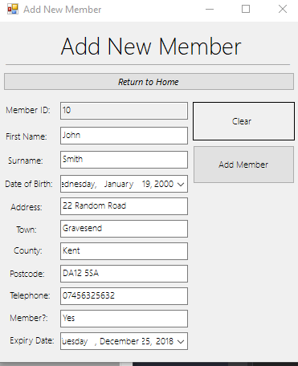

When I click “Add Member”:
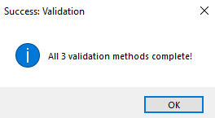

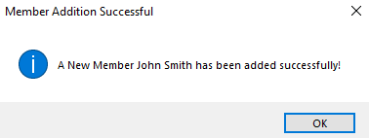

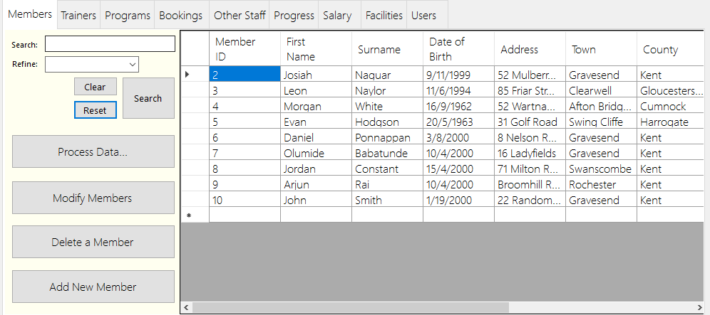
As you can see below, the addition was successful, and now shows on the table within the main form when the “reset” button is selected.

4e and 4f- Evaluation of the prototype and suggestions for improvement.
In this section of the prototype section I will be evaluating both the performance and functionality of my prototype, as well as justifying the good features of the prototype and describing the shortcomings. I will then suggest improvements which can be made to the final product, to ensure that the project is successful.
Positive Features:
Login
- The login feature is now fully functional and works as intended. The user can input various usernames and passwords which correlate to the UserFile and then gain access to the main form. There is also different levels of access, as only the ‘admin’ can see the passwords on the datagridview.
- The user can input the username, password and then click the enter button to go into the program.
- If the password is incorrect, then the user cannot get into the program.
- The login has adequate aesthetics and text effects within the boxes saying the box’s purpose (e.g. “password”), this gives the program a modern aesthetic, making it more welcoming for the user.

Adding Records
- Records can be added for all the tables, including users. Each record can be set specifically and accurately.
- There is validation when adding records for all tables, this includes: presence check, type check and length check. These validation types work as intended for each form and are tailored to the data sets and datatypes it correlates to (E.g. date ranges, text length ranges).
- Each record addition is separated into forms based on what table the record is being added to and has the according input boxes.
- Dates can be entered via a date/time picker for the corresponding forms and ID’s can be selected via a drop-down menu.
- There is also a “clear button” to clear all the text boxes as well as a “return to home” button on each form, to close the form itself.

Modifying Records
- Records can be searched for and refined by various parameters (e.g. by their ID, First Name, Capacity, etc.)
- Multiple datasets on records can be changed at once (e.g. First Name and Home address can both be changed simultaneously).
- Modifying records works as intended.

Deleting Records
- Records can be deleted promptly and effectively.
- The record can be selected via a drop down which shows a parameter such as a full name or a name (e.g. John Smith or Swimming Pool) to make identification easier and more user-friendly.
- There is a messagebox which asks if the user is sure, which prevents mistakes from occurring or accidental deletion.
- The amount of records within the list is shown after deletion.

Basic Analysis
- Analysis has been implemented into the program and works,
- However, there are issues with the grouping of the bars, which I hope to address in the software development.

Improvements:
There are various improvements which can be made to the prototype, this being to enhance the user experience or to improve functionality, for example:
Inclusion of a Logo
- The current prototype lacks any logos or branding of the company, which can make the program look generic and unprofessional.
- The inclusion of a logo would not only make the program look more inviting, but would also distinguish the program and adds a sense of refinement to it.

Closing the program
- Add an “x” button to close the login form, as once you log off; you’re stuck on the login screen unless you close the program manually via the taskbar.
- Making the logout button more clearer, and potentially a messagebox warning beforehand.
Layout
- Potentially change the layout of the buttons on each tab, by making the buttons smaller or increasing the gap.
- Experimenting with font changes to improve the aesthetics of the program.

Analysis
- Attempt to address the repeating bar issue, If not: specify this issue and make it clear to the user.
- Make colour or aesthetic changes to the analysis section, to improve readability as as well as making it more approachable.

